Auto Fill SABR Worksheet Version II
  - Wednesday, July 19, 2021

Save the DVH Data
- Open the DVH view in External Beam Planning
- In the "Dose Statistics" Tab Right -Click on the "Show DVH" column
- Select "Show DVH for all Structures"
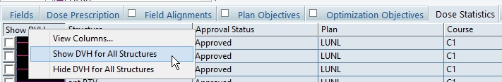
- DVH values will be calculated

- Right-Click within the DVH
- Select "Export DVH in Tabular Format…"
- A “Save As” dialogue box will appear.
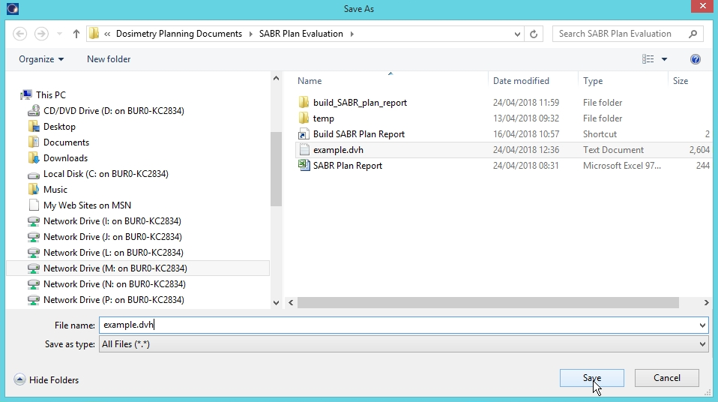
- Select the folder:
  - M:\Dosimetry Planning Documents\SABR Plan Evaluation\DVH Files
- Change "Save as type" to "All Files"
- Enter a file name ending with ".dvh"

Run the Plan Evaluation program,
- Run "PlanEvaluation"
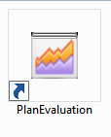
- The main window appears:
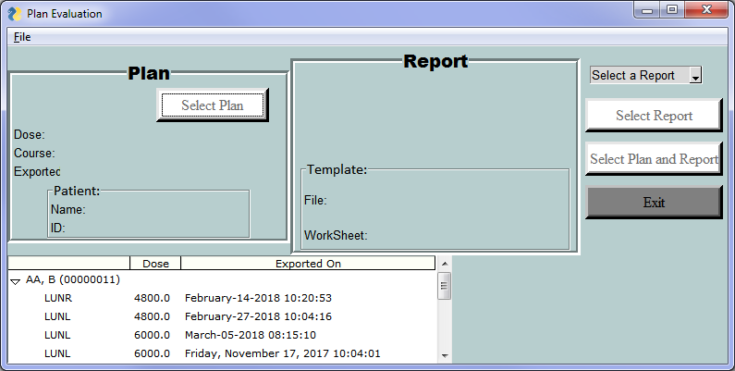
- Select the dvh file from the list in the bottom left of the window.
(This is a list of all dvh files in the directory:
M:\Dosimetry Planning Documents\SABR Plan Evaluation\DVH Files directory)
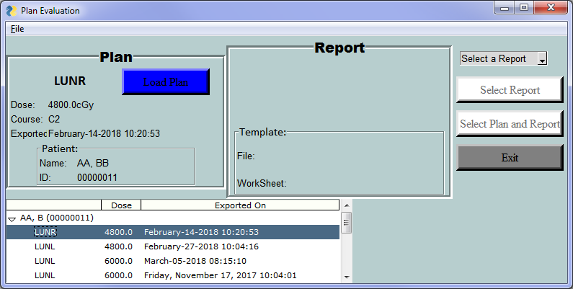
- Click on "Load Plan" to import the dvh file data
- The dvh file will load and the button label will change to “Plan Loaded”.
 | → | 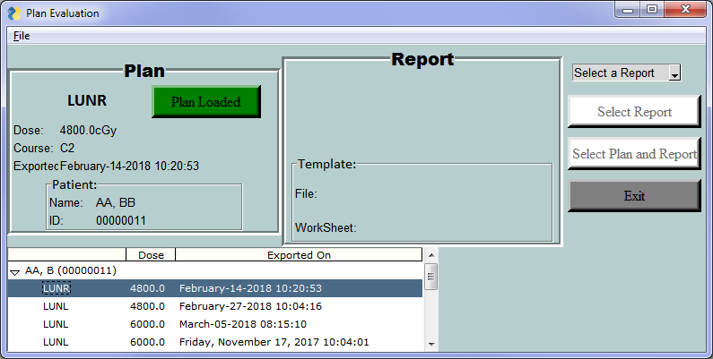

- Select the appropriate Report from the drop-down menu in the top right.
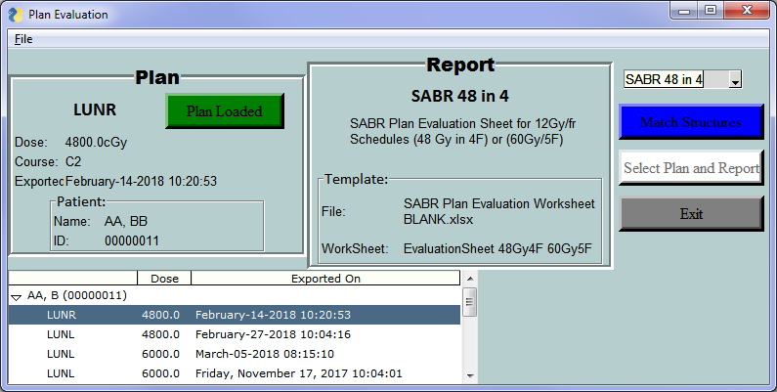
- Click on the “Match Structures” button.
- A new window will pop up allowing you to Match the Plan Report Items with structure names.
- The items are grouped by whether the auto-match was successful or not.
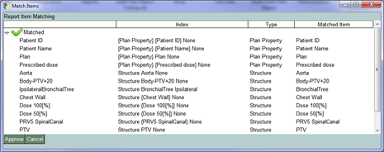
- To manually match a structure to a given report item:
  - Right click on the Click on the desired item and hold the mouse over the Match heading on the menu that appears.
  - Click on the appropriate structure from the list:

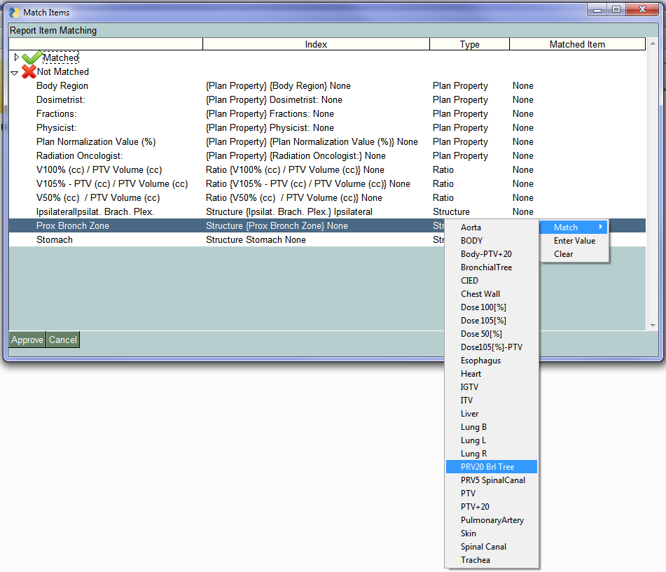
- It is also possible to manually type in text:
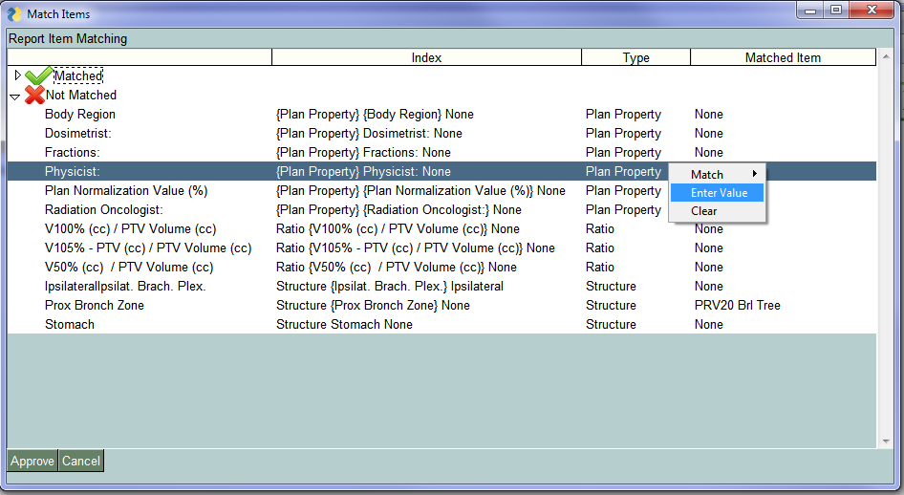Match Structures” button.
- Selecting “Enter Value” from the right-click menu brings up a new window for typing in the text value
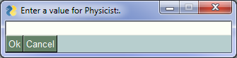
- The value entered will display in the Matched Item column:
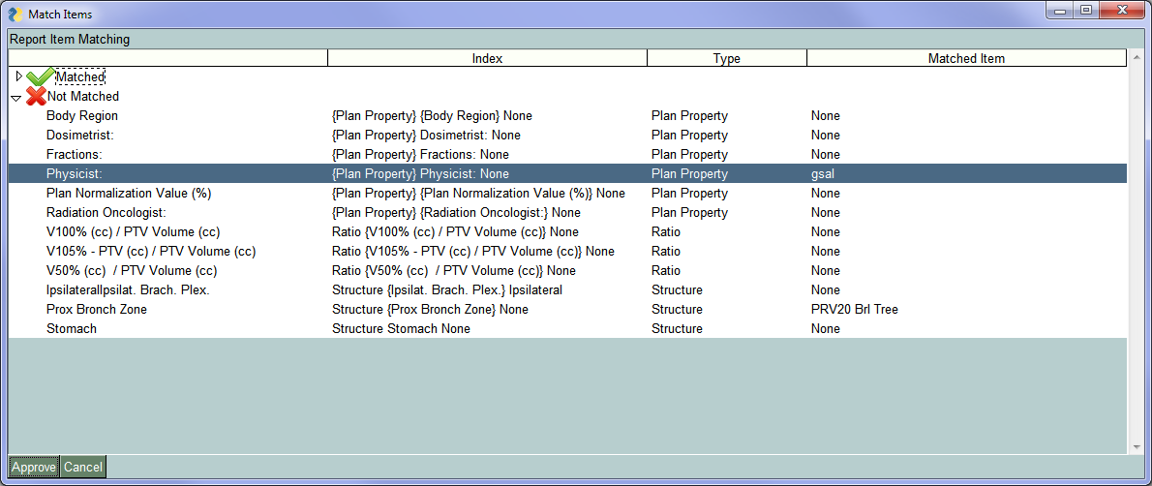
- To remove a match, select “Clear” from the right-click menu”
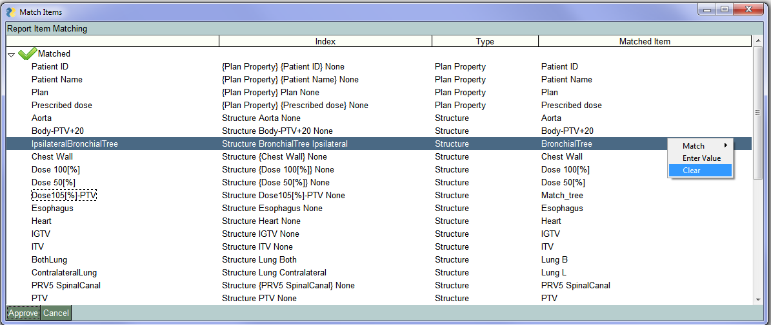
- The value in the Matched Item column will become “None”:
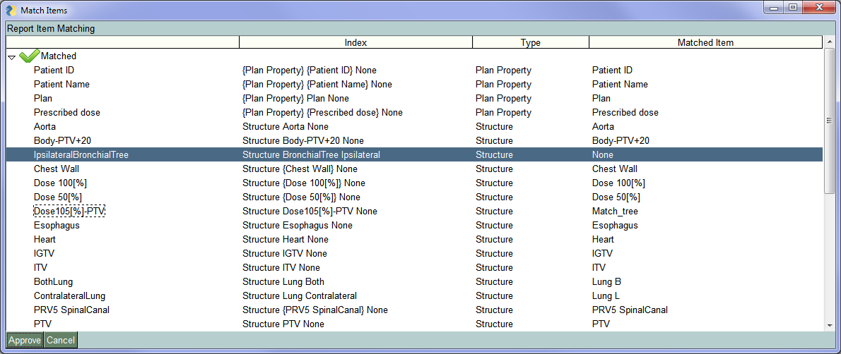
- Once all desired modifications are complete, click on the Approve button in the lower left corner.


- Click on “Generate Report”
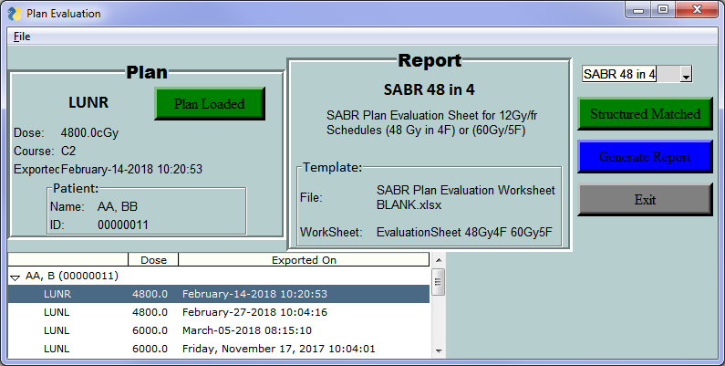
- The SABR Plan Report Form will appear and begin to populate
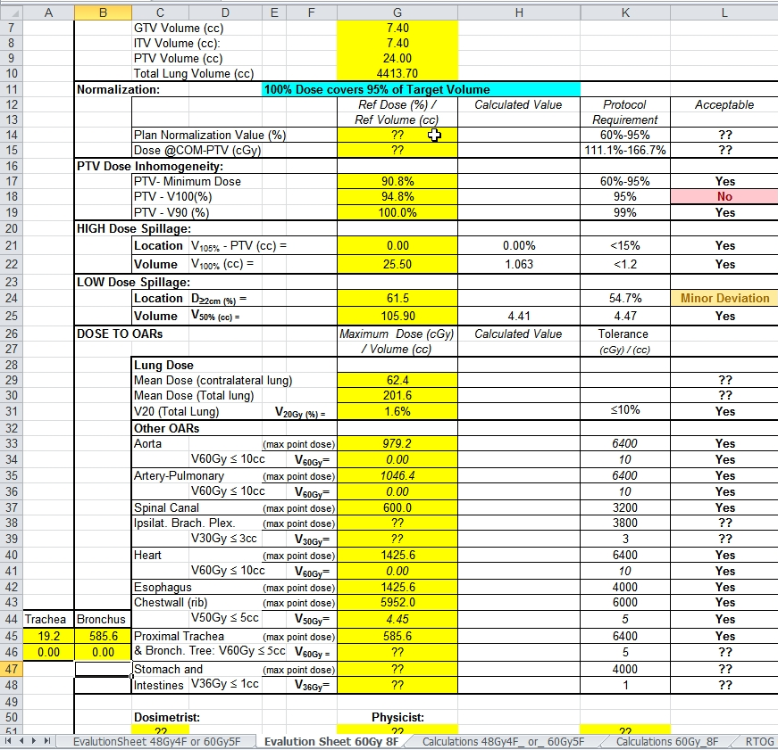

Review Results
- There is a slight difference from that standard form in that values for both Trachea and Bronchus appear, but the maximum of the two goes in the usual spot.
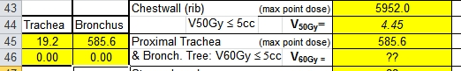
- Clicking on any of the green buttons, selecting a new dvh file or plan report will move back to that step in the process.

Note
- This program is a work in progress.
  - Some things will not work as intended
  - Your feedback / bug reports / feature requests are very welcome

